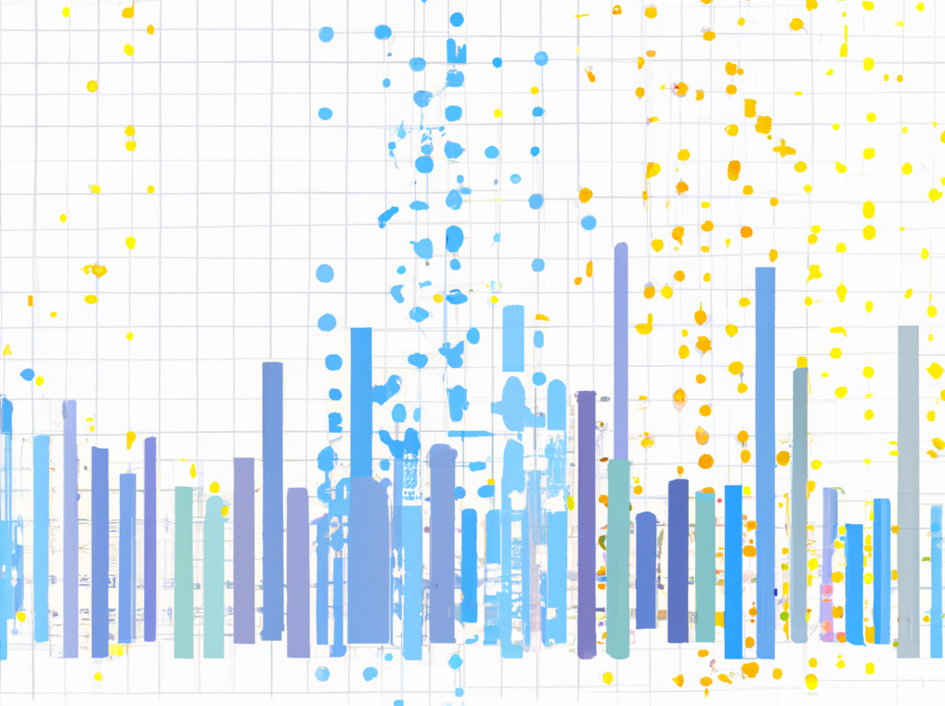

THE PRICE ISN’T RIGHT: VISUALIZING THE COST OF LIVING

COS30045 - DATA VISUALISATION

1927 WORDS

Rubie Stannard: 103982732

## **Table of Contents**

1. Executive Summary2
2. Introduction3
   1. Background3
3. Body4
   1. Cost of Living in Australia4
      1. Data Efficiency4
      2. Visualization Effectiveness4
      3. Improvement Suggestions5
   2. The Cost of Energy6
      1. Data Efficiency6
      2. Visualization Effectiveness7
      3. Improvement Suggestions8
   3. CPI v WPI 2022 Growth9
      1. Data Efficiency9
      2. Visualization Effectiveness10
      3. Improvement Suggestions11
4. Conclusion12

References13

## **Executive Summary**

Since December 2021, prices in Australia have increased due to COVID-19, global issues, and disasters such as floods. This report critiques visualizations containing data about the different aspects of cost of living in Australia. Specifically, it examines the price of Australian grocery staples amidst the cost-of-living crisis. Additionally, it looks at the average quarterly gas bill in Australia by state. Finally, the report analyses the growth of the 2022 Consumer Price Index compared to the Wage Price Index. The report concludes with findings of the CPI increasing without the any signs of the WPI increasing, and the recommendations that Australians should move to a cheaper state or lower their standards if they’re looking for cheaper ways to live.

## **Introduction**

## **Background**

As more global and environmental disasters occur, the prices in Australia increase, as well as the populations distress levels from the cost-of-living crisis. As Glenn (*2023*) writes, the Royal Bank of Australia raising the cash rate 10 consecutive times has left the inflation rate at 7.8%, which is the highest it’s been since 1990, and Australians expect it to continue rising.

Groceries, housing, utilities, and almost everything that costs money, costs more. Finder research has found that “11 million Australians are taking action to deal with rising costs, including 48% who have dropped their living standards” (*Glenn, 2023*). Regardless of how you look at this crisis, no matter how expensive the cost of living becomes, people will continue to spend money in order to survive.

Through the use of visualizations, which have been used to convey different aspects of this cost-of-living crisis, this report will be exploring how expensive groceries have become, the average price of a gas bill, and how much wages have increased during this crisis. These questions will be answered by analysis the visualizations to determine how efficient and effective the data is, as well as suggestions on how they could be improved.

## **Body**

## **Cost of Living in Australia**

### **Data Efficiency**

The first visualization is Budget Directs visualization that uses multiple bar charts to display the cost of groceries in Australia.

*Figure 1. Price of Australian groceries amidst the cost-of-living crisis (Budget Direct, 2022).*

The data in Budget Directs visualization shows quantitative ratio data expressed as the price of groceries. This data has been visually encoded into a horizontal bar graph, which is appropriate for representing prices. The only issue with the visual presentation is the cigarettes. This part of the encoded data doesn’t match the rest of the visualization when it could’ve been represented in the same way as the other data.

### **Visualization Effectiveness**

As well as being efficient, a visualization has to be effective. Budget Directs visualization is effective in providing Australians with a general idea of what groceries cost.

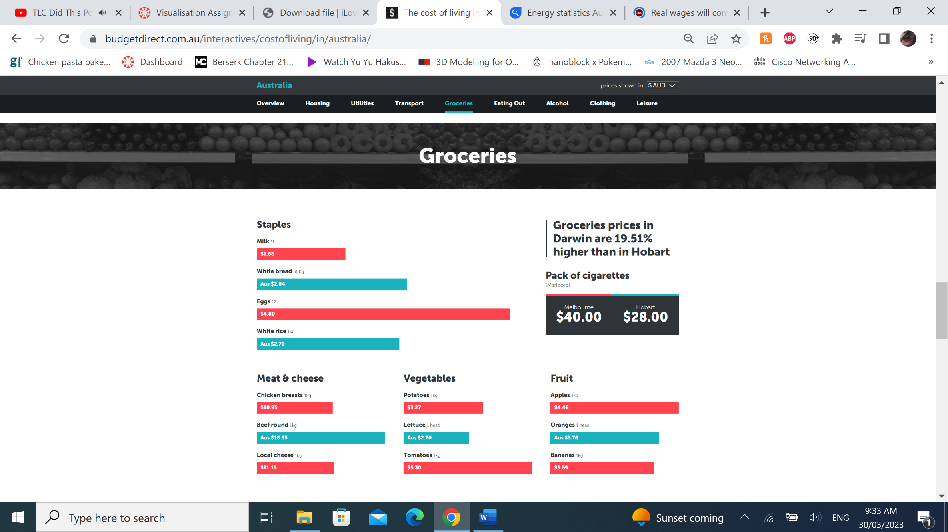

*Figure 2. Price of Australian groceries amidst the cost-of-living crisis (Budget Direct, 2022).*

If users are looking to the visualization for the general price of groceries, then they’ll find an answer. However, this visualization only provides a general overview, so if users wanted to know the exact prices of the groceries used in the visualization, or if they wanted to know the price of groceries that aren’t shown, the user will not find an answer in Budget Directs visualization. Due to the data being a general overview, and prices varying in shops and states, the values shown on the visualization won’t apply to everyone who views it, potentially misleading some users.

Budget Directs visualization can be accurately read, and Based on Tufte’s Principles of Graphical Integrity, the visualization follows good design principles. The scale of the grocery prices is proportional, the labelling is clear, the colour shows variation in the data, the prices are shown in AUD, the visualization is 2-dimentional, and none of the data is out of context.

### **Improvement Suggestions**

Although Budget Directs visualization efficiently and effectively displayed the price of groceries, in my opinion, minor improvements can be made to make the visualization look a bit neater.

*Figure 3. Price of Australian groceries amidst the cost-of-living crisis (Budget Direct, 2022).*

The major improvement would be the weight being the same. The grocery prices are based on the weight, and some groceries have a different weight. To make the data more consistent, each item could be 1kg. Another improvement suggestion is adding a date to this data, so Australians know when groceries were the price shown in the visualization. Other small changes could be made, such as the pack of cigarettes matching the other data, or the grocery price in Darwin statistic could be removed, but I feel like the biggest improvement would be the weight being consistent.

## **The Cost of Energy**

### **Data Efficiency**

The second visualization is Finder’s geo chart representing the average gas bill by state (quarterly).

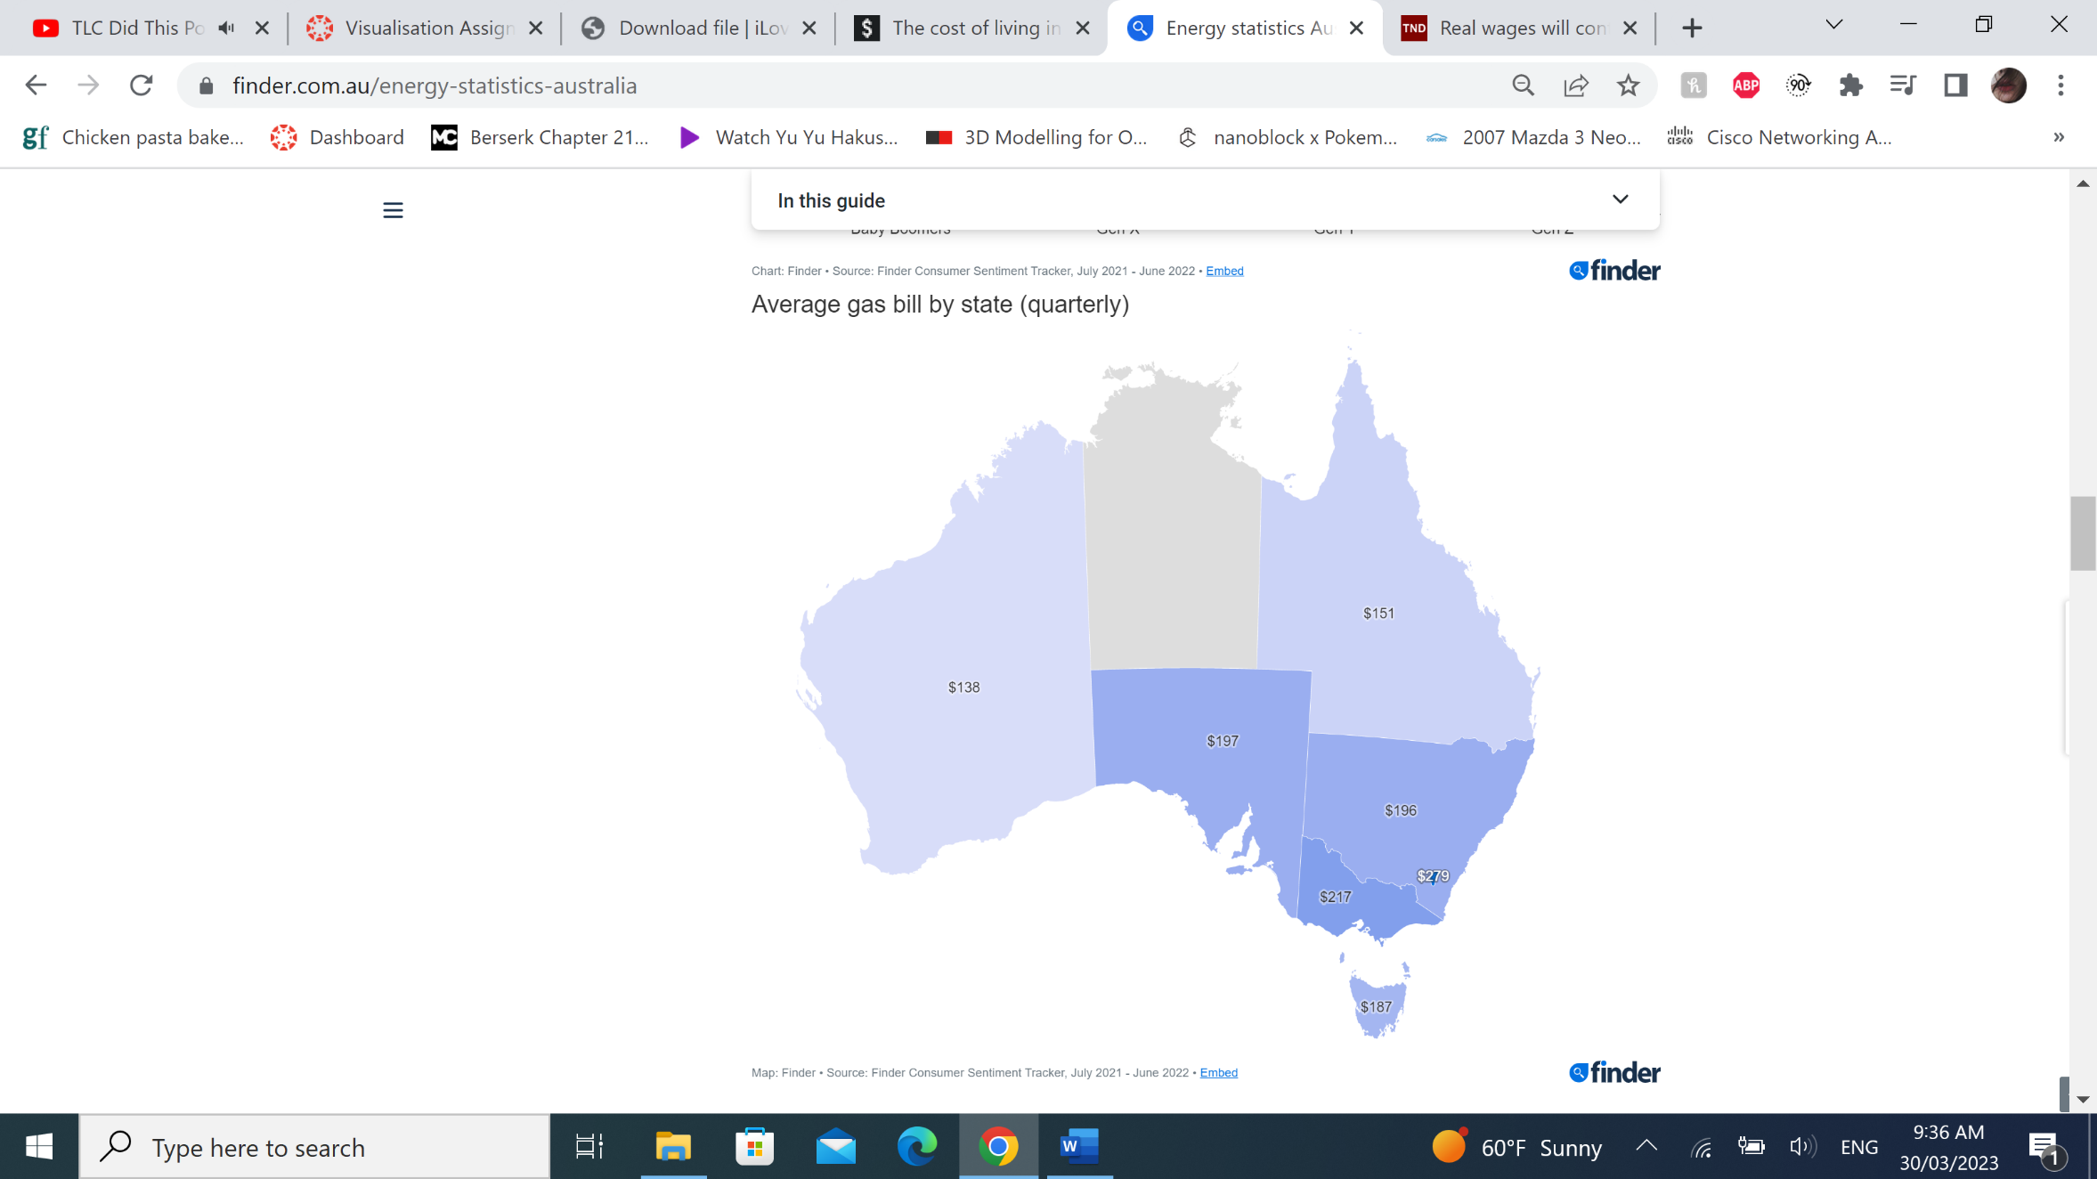

*Figure 4. Finders average quarterly gas bill in Australia by state (Wallis, 2022).*

The data shown in Finder’s visualization is quantitative ratio data expressed as the cost of a gas bill. This data has been encoded into a geographical chart of Australia, which is appropriate for comparing the cost between states. There are no issues with the type of data used or how it has been presented.

### **Visualization Effectiveness**

Finder’s geographical chart is mostly effective, but the lack of data for the Northern Territory means the visualization isn’t as effective as it could’ve been.

*Figure 5. Finders average quarterly gas bill in Australia by state (Wallis, 2022).*

As stated above, Finder’s visualization is effective, aside from the Northern Territory lacking data. If users wanted to see the average gas bill comparison by state and weren’t bothered by the Northern Territory having no data, the visualization clearly provides the users with an answer. If viewers wanted to use this visualization to compare the price of a gas bill between a state and the Northern Territory, or they wanted to know the cost of the average quarterly gas bill in the Northern Territory, this visualization wouldn’t be able to provide them with an answer. This visualization could be misleading if users don’t read the title.

Using Tufte’s Principles of Graphical Integrity, the visualization follows good design principles, although not every principle applies to this visualization. The principle of numbers on the graph being “directly proportional to the numerical quantities represented” (*R, 2020*) doesn’t apply because the visualization is of Australia, and the size of each state can’t be changed. Anyhow, the remaining principles can be applied to Finder’s visualization. The labels are clear, the colour shows the variation in data even though each state isn’t a different colour, the monetary measurement is in AUD, the visualization is 2-dimentional, and no data is out of context.

### **Improvement Suggestions**

For Finder’s geographical chart, I only have two improvement suggestions, and although one of these suggestions might not be doable, it’s a suggestion that I think would make the visualization look better.

*Figure 6. Finders average quarterly gas bill in Australia by state (Wallis, 2022).*

The first suggestion would be to include the data for the Northern Territory, so the visualization looks complete. The second suggestion would be to use a different shade of violet for each state. Each state has different data, and I think the different values should be represented by different colours for this geo chart. These improvements would make the visualization look more complete but wouldn’t be necessary to be able to understand the question the visualization is answering.

## **CPI vs WPI 2022 Growth**

### **Data Efficiency**

The final visualization is The News Daily’s area graph comparing the growth of the 2022 Consumer Price Index and the Wage Price Index.

*Figure 7. The News Daily’s growth of the 2022 CPI vs WPI (Bakan, 2023).*

The data used is The News Daily’s area graph is quantitative ratio data, which is the same as the data in the other visualizations. However, this data represents the WPI can CPI percentage of each month in 2022. This data has been encoded into an area graph, which is appropriate for showing the changes in percentages over time. The only issue I have with the visual presentation is the title. The font is much bigger than the other text, and the colour shouldn’t be red.

### **Visualisation Effectiveness**

The News Daily’s area graph is effective for conveying the growth of and comparing the CPI and WPI throughout 2022.

*Figure 8. The News Daily’s growth of the 2022 CPI vs WPI (Bakan, 2023).*

Australians who are looking for a visualization that compares the consumer price index with wages, The News Daily’s visualization will be able to show them. The data might not be as clear as the other visualizations since some of the points are in the middle of percentages. The visualization is interactive, so users can see the percentage of each month on the website, but not in this image. This might make the data seem less clear for some users, but the data is not misleading.

If The New Daily’s visualization is analysed using Tufte’s Principles of Graphical Integrity, the visualization will follow good design principles. The “standardized units of monetary measurement” (*R, 2020*) principle doesn’t apply to this visualization since there is no money in the visualization. The data is correctly scaled to represent how large the gap between the areas is, and the labelling is correct, but it could be clearer if the font was black. The colours and graph clearly show the variation in the data, and like the other ones, this visualization is also 2-dimentional and none of the data is out of context.

### **Improvement Suggestions**

The improvement suggestions for this graph are mostly for aesthetic reasons, but having darker text could be for usability purposes.

*Figure 9. The News Daily’s growth of the 2022 CPI vs WPI (Bakan, 2023).*

As mentioned above, the label font could be black instead of grey so it’s easier to read. A dot could be added for to each month so the graph is more visually appealing, and the title font should be the same font type as the other font on the visualization, and it should be black instead of red. Personally, I think this visualization doesn’t look as good as the other visualizations, but I think the improvements I suggested could make it look a little better.

## **Conclusion**

From each of the analysed visualizations, it’s clear to see that the prices of necessities are high, even though Australian wages are low. Based on the trend seen in The News Daily’s CPI v WPI 2022 Growth, it appears as though the CPI will continue to increase without a wage increase. If the average Australian is looking for cheaper ways to live, according to the data in Finder’s Average gas bill by state (quarterly), moving to Western Australia could be a solution. However, if Australians don’t want to move to a cheaper state, as found by Glenn (*2023*), they could join the 48% of the 11 million Australians who have dropped their living standards.

## **References**

Bakan, S. (2023) *Wages will still lag inflation in 2023, even as pay packets get fatter, The New Daily.* Available at: <https://thenewdaily.com.au/finance/2023/02/03/wages-growth-inflation-2023/> (Accessed: March 18, 2023).

*The cost of living in Australia* (2022) *Budget Direct Insurance.* Available at: <https://www.budgetdirect.com.au/interactives/costofliving/in/australia/> (Accessed: March 18, 2023).

Glenn, A. (2023) *Cost of living in 2023, finder.com.au.* Available at: <https://www.finder.com.au/money/cost-of-living#:~:text=The%20cost%20of%20living%20in,it%20has%20been%20since%201990>. (Accessed: March 18, 2023).

R, R. (2020) *Edward Tufte's Six Principles of Graphical Integrity, LinkedIn.* Available at: <https://www.linkedin.com/pulse/edward-tuftes-six-principles-graphical-integrity-radhika-raghu> (Accessed: March 30, 2023).

Wallis, S. (2022) *Energy statistics Australia 2022, finder.com.au.* Available at: <https://www.finder.com.au/energy-statistics-australia> (Accessed: March 18, 2023).